# Current Advert Campaigns

## analysis

### WWF (example):

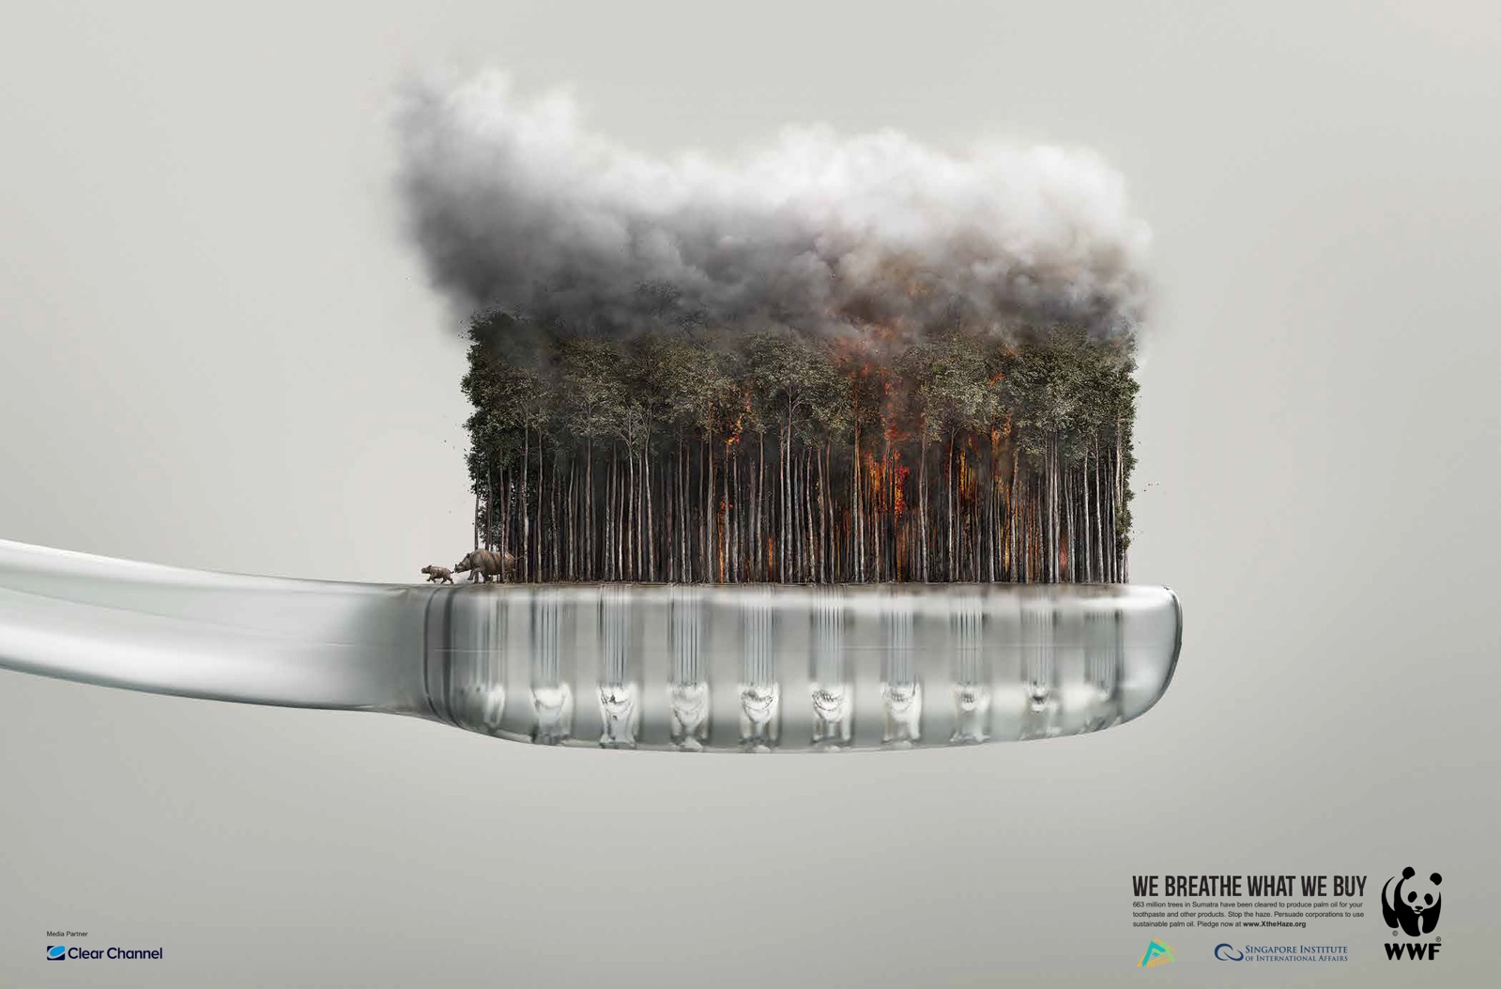

This successful poster uses techniques such as shock and an infeasible scene to draw the audience’s attention. The use of a familiar household object such as the disposable tooth brush helps make the poster relevant to people and make the audience feel more responsible for problem they are describing as generally people tend to separate themselves from the damage humans, generally, are causing. We hope to do this in our app by working out statistics based upon the user’s data which will display information such as how much ice they, personally, have melted this year or how many polar bears the have killed.

These posters show the world wasting away like a melting ice cream. This imagery gives the audience something to think about and could make them feel more responsible for their actions due to the personal familiarity we have with ice cream. It should also make them think on how they can change their habits to make the economy/environment a better place.

